A GUIDE TO SMART PLS

First we need to convert the SPSS data into a .csv file before SmartPLS can read the input data. Click File Save As then choose “comma delimited (.csv)”. Give a new file name “TPB PLS” and save.

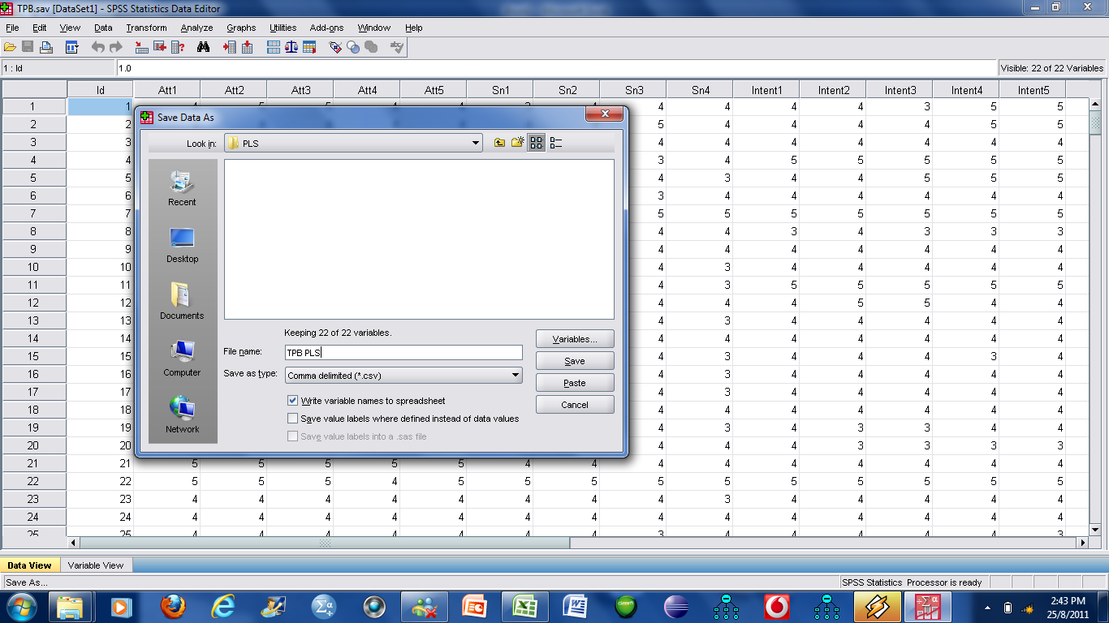

When you start the SmartPLS program, go to New, Create New Project.
Type in a name example: TPB Analysis

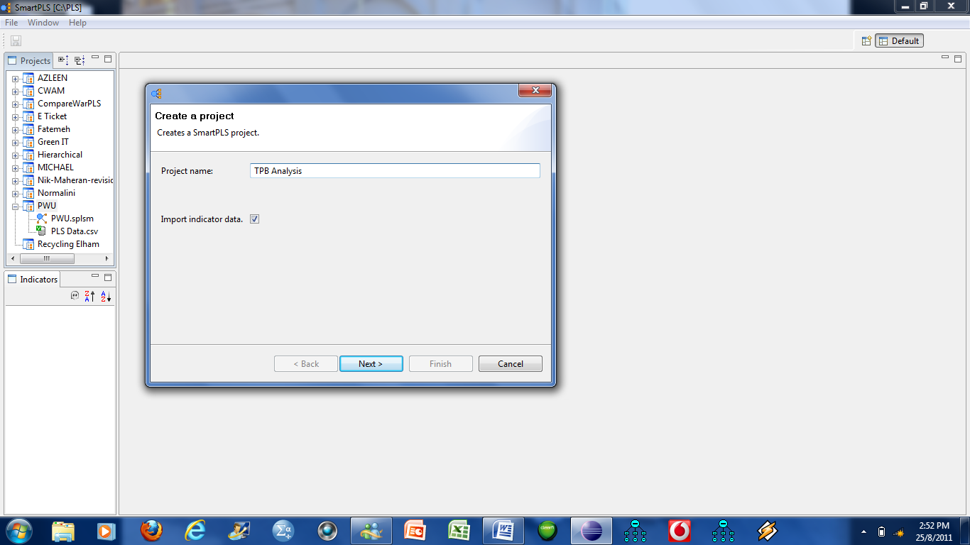

Then Click Next

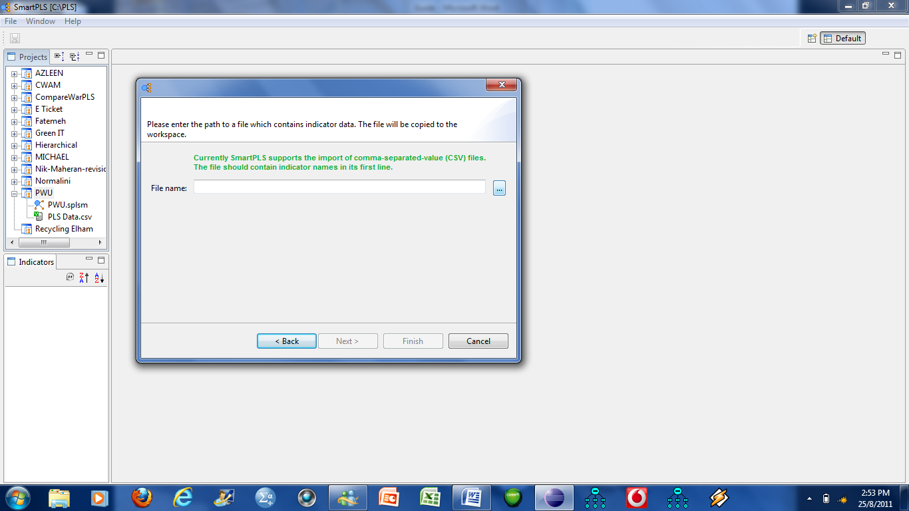

Click this button and look for the file you saved as .csv earlier from SPSS; “TPB PLS”.
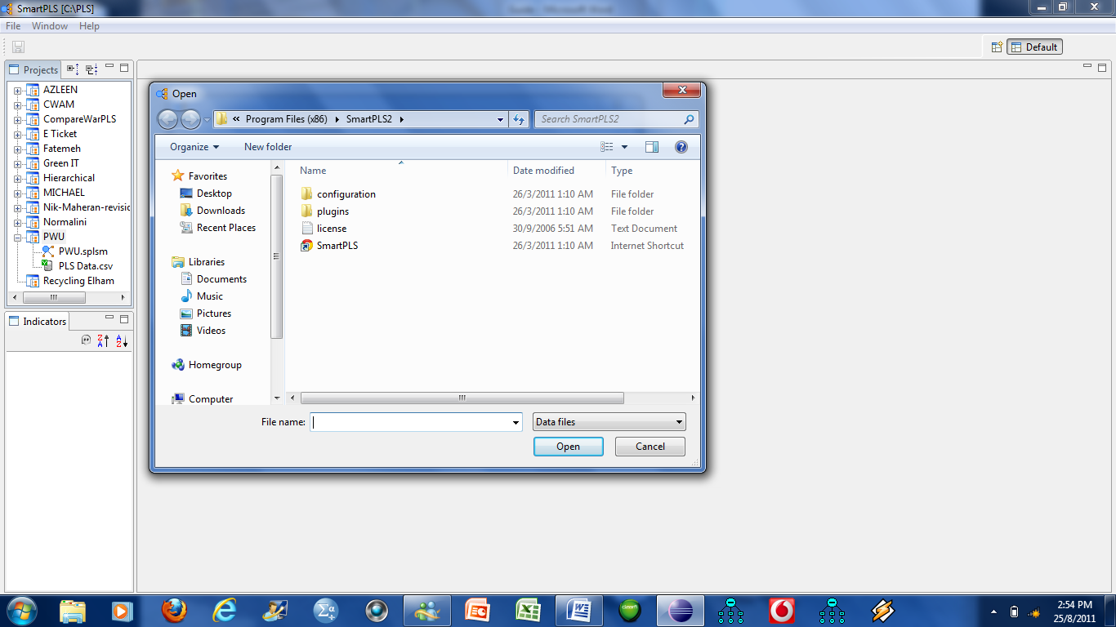

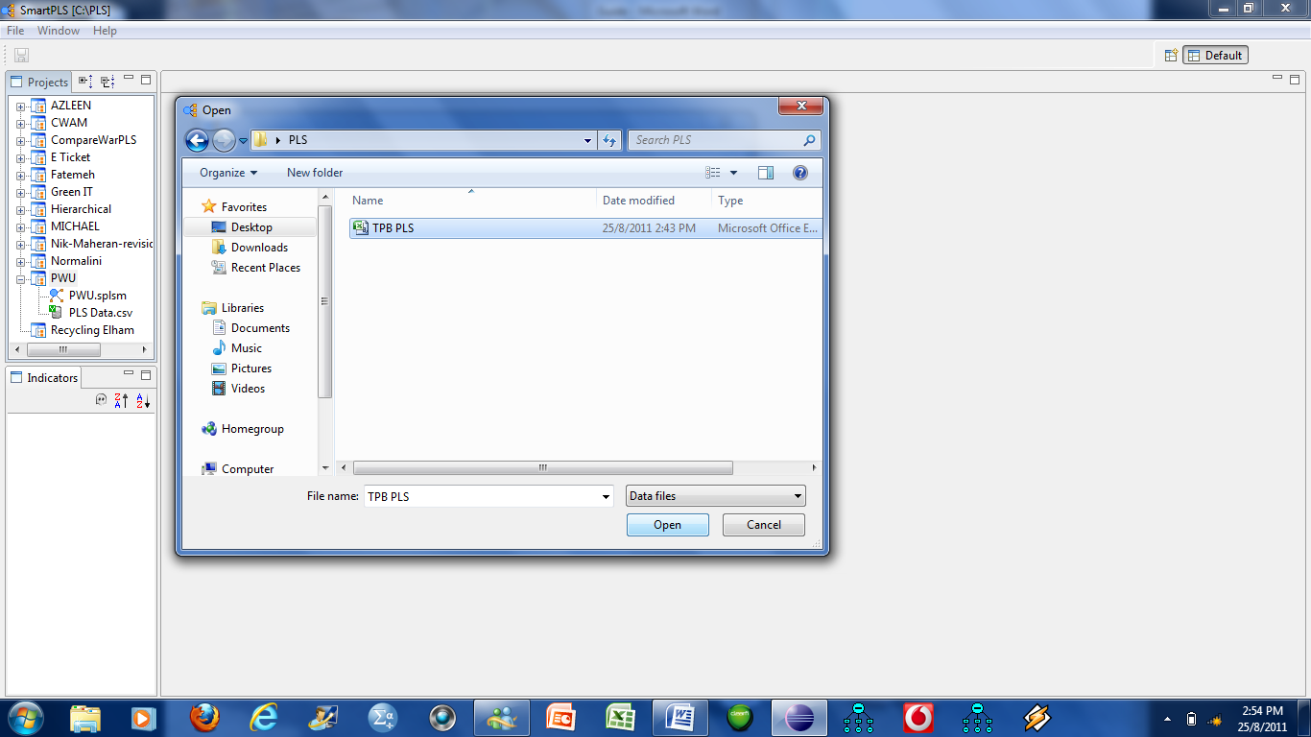

Click Open
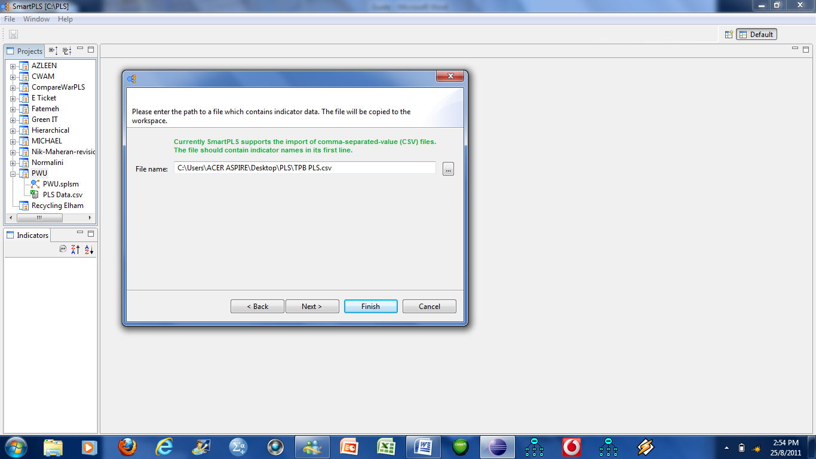

Click Next

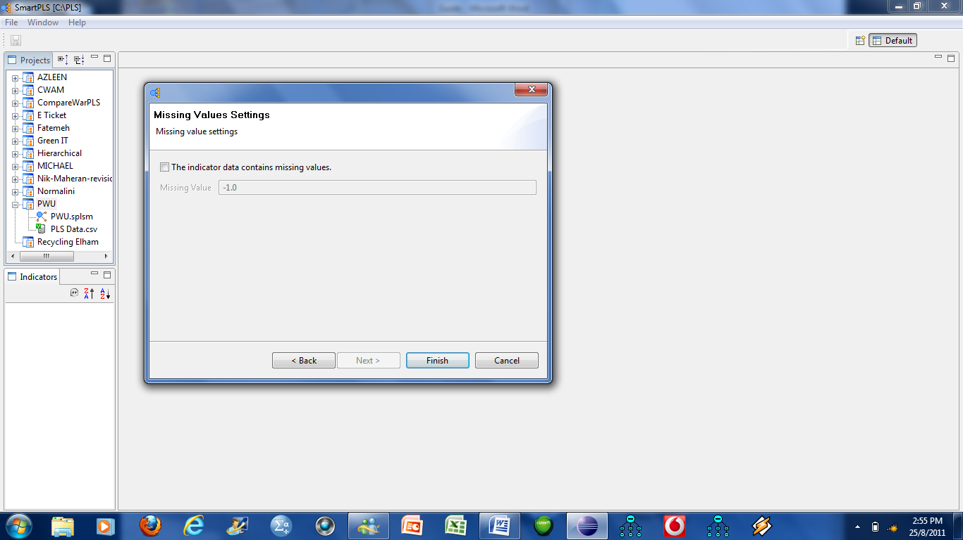

If you have missing values you need to specify them here, ie; what values you have used.

Make sure the file has a Y, if it shows ?, then no indicators will be displayed in the Indicators window

This is the canvas where you start drawing.

You click this button to switch mode from insertion of latent variable or drawing lines.

You click this button to draw latent variables.

You click this button to draw lines.

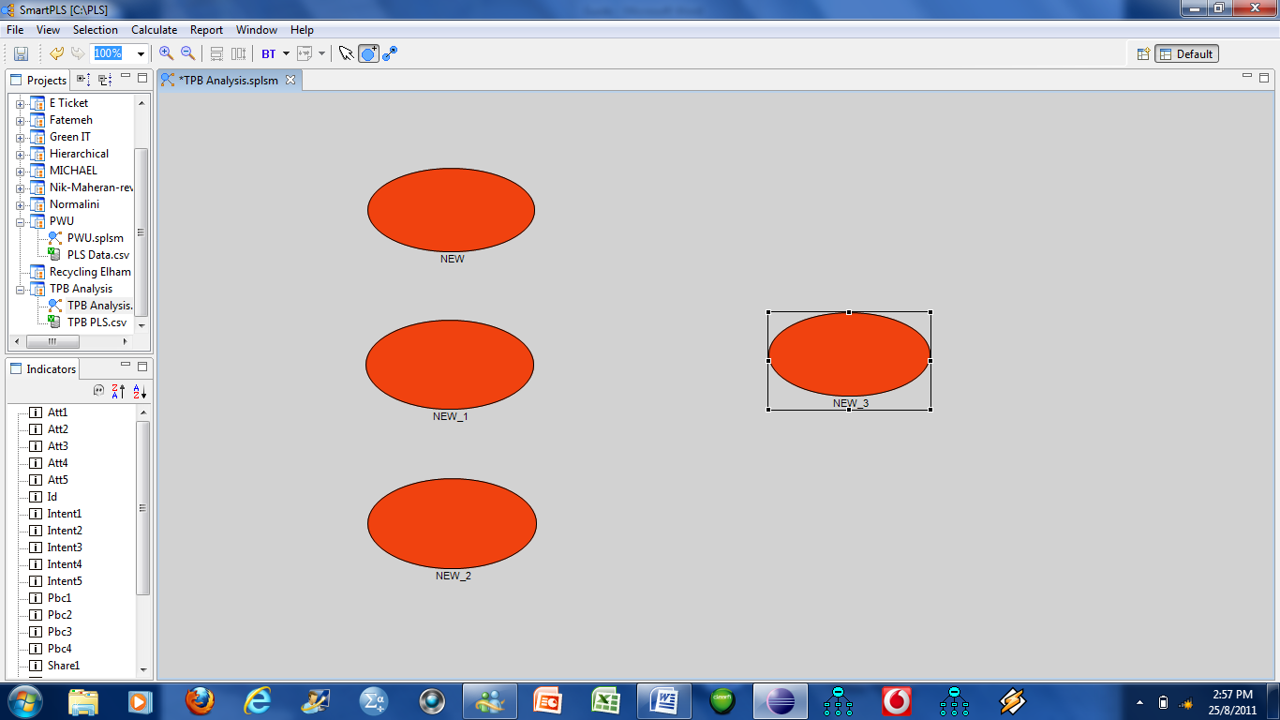

First draw the latent variables.

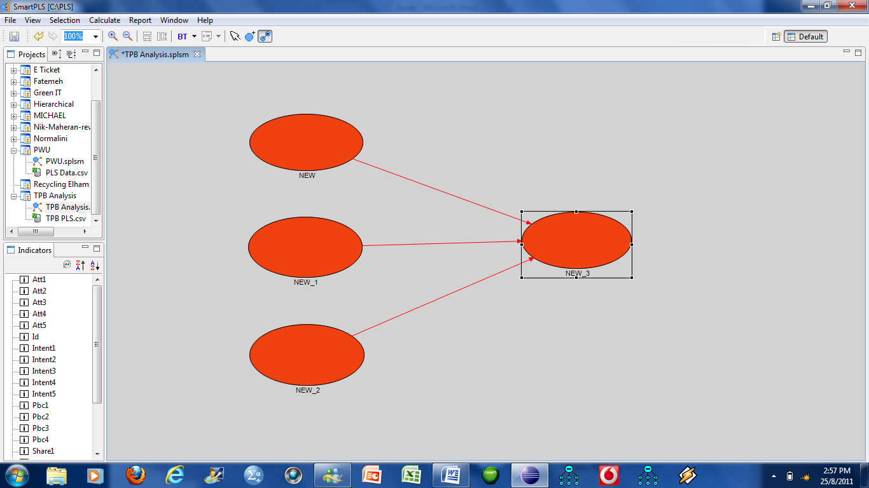

Then link the latent variables.

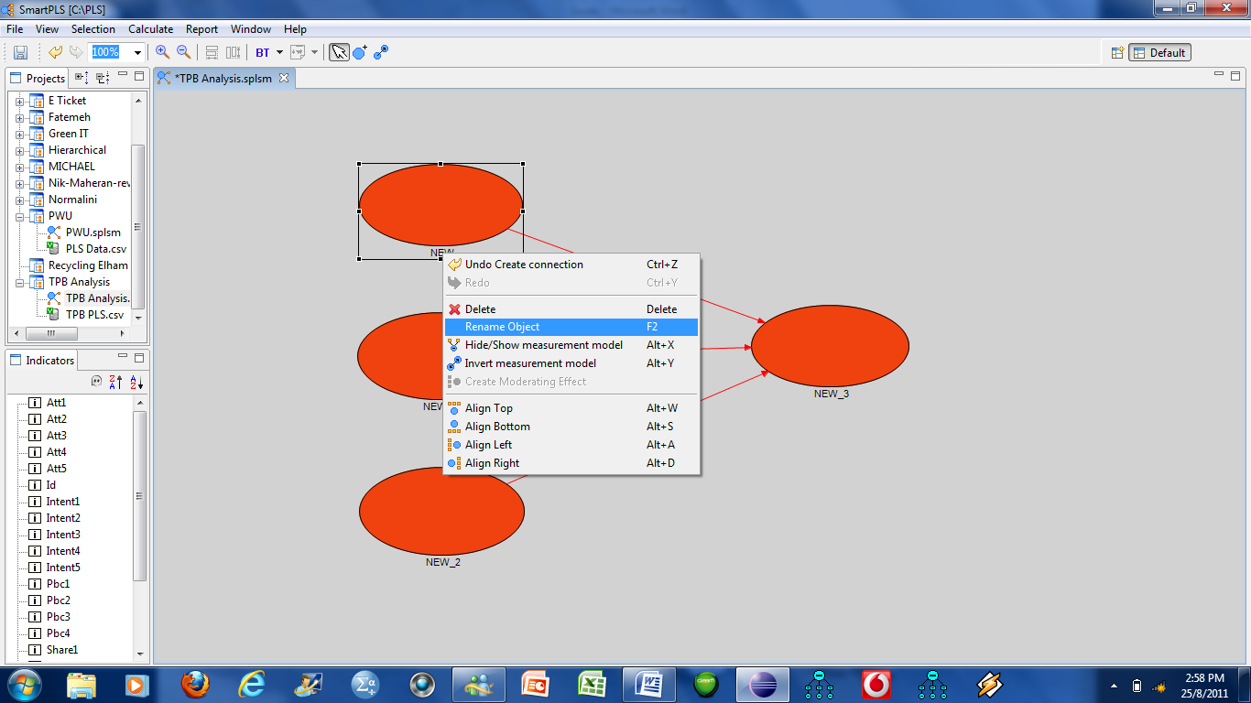

Right hand click at the latent variable, then change the variable name one at a time.

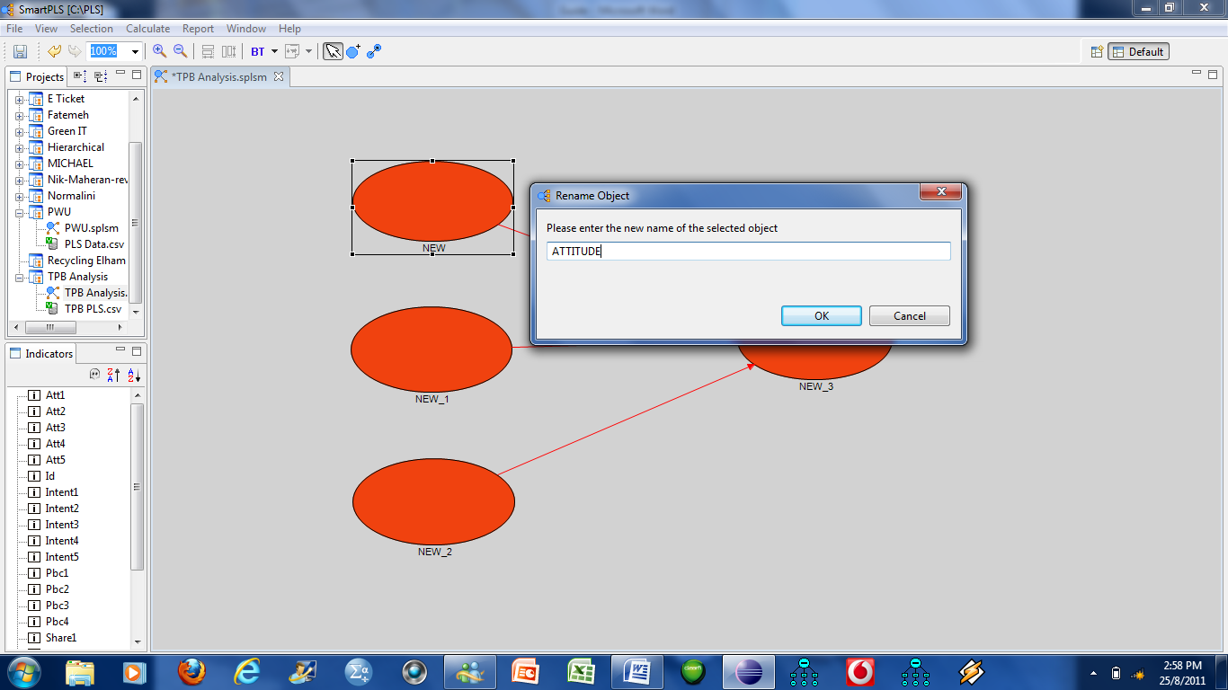

After labelling, click Ok and repeat for the rest.

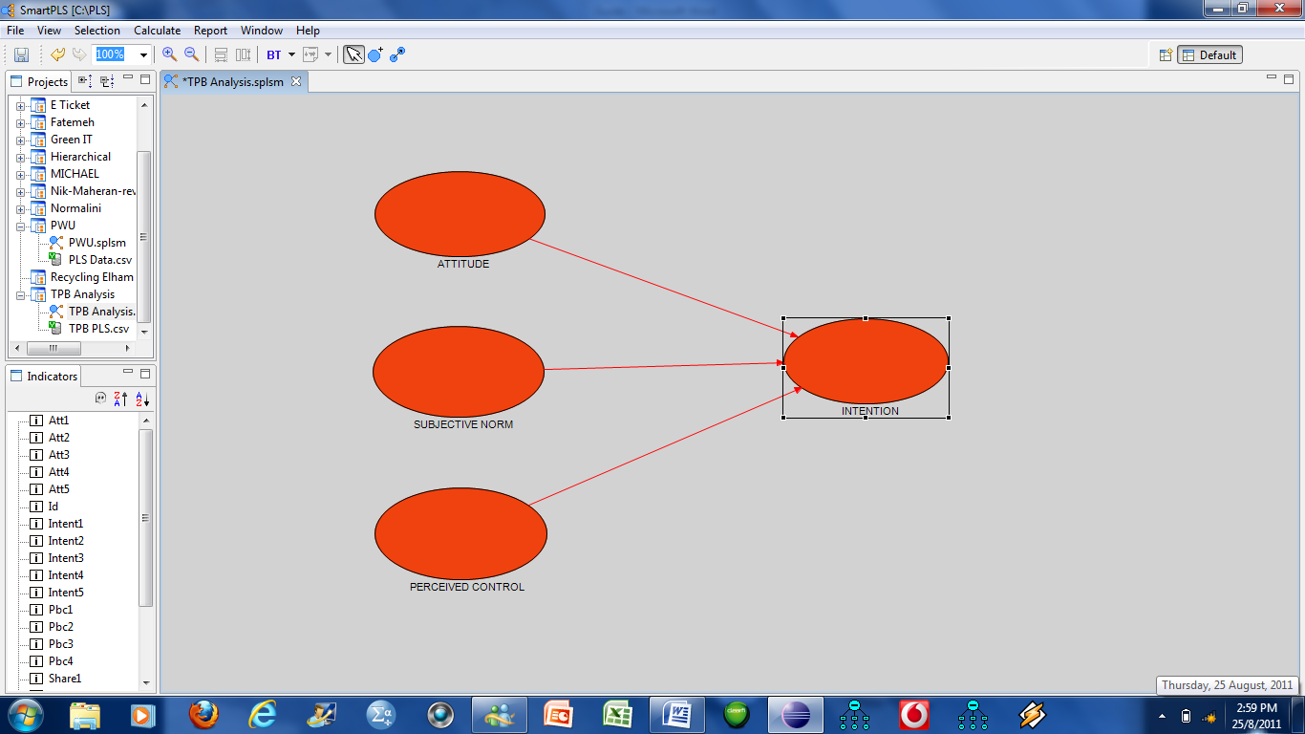

Once labelled, you need to drag in the items.

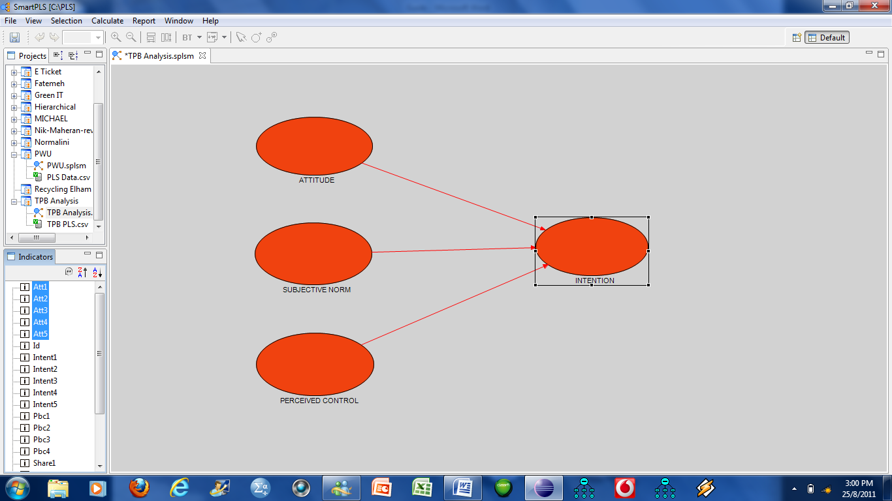

Under the window indicators, highlight Att1 to Att5, drag and drop inside the circle.

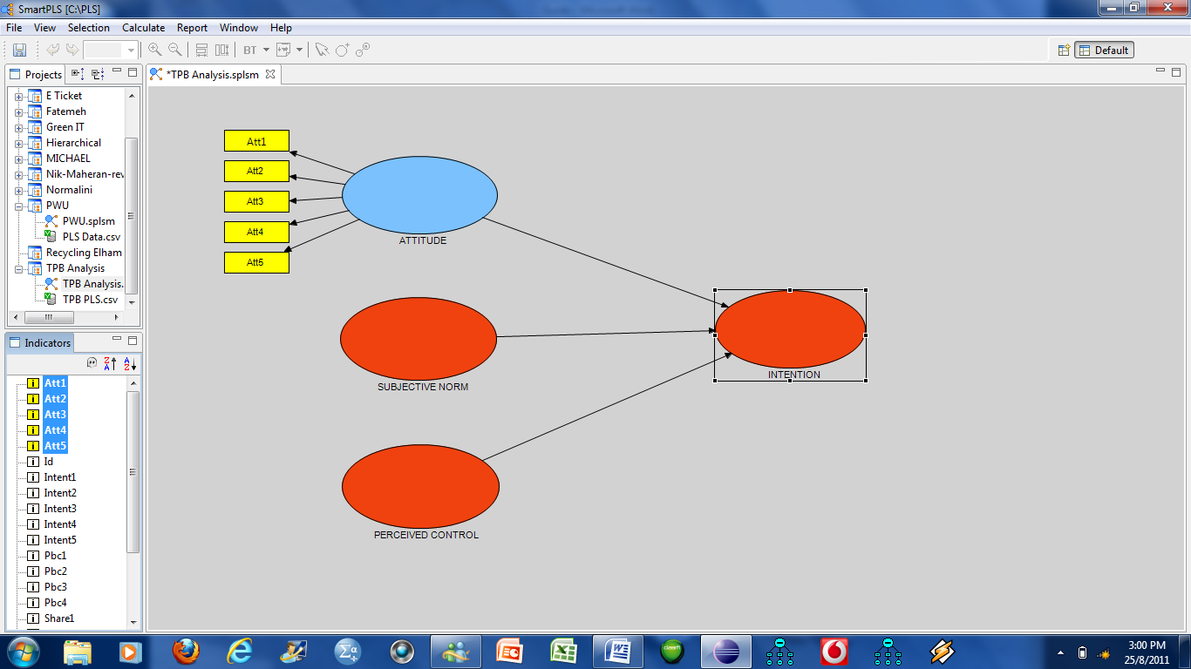

Then select the other indicators for the respective latent variables.

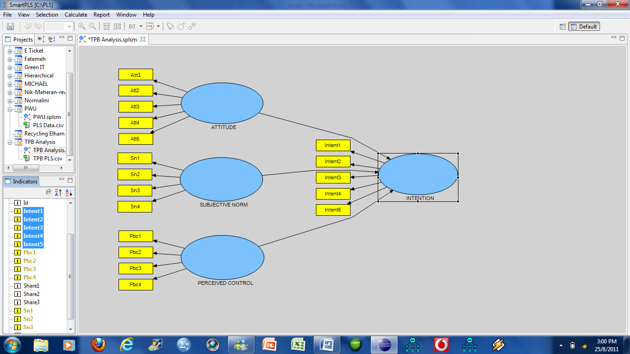

For Intention the items are aligned left so we need to change them to be aligned right.

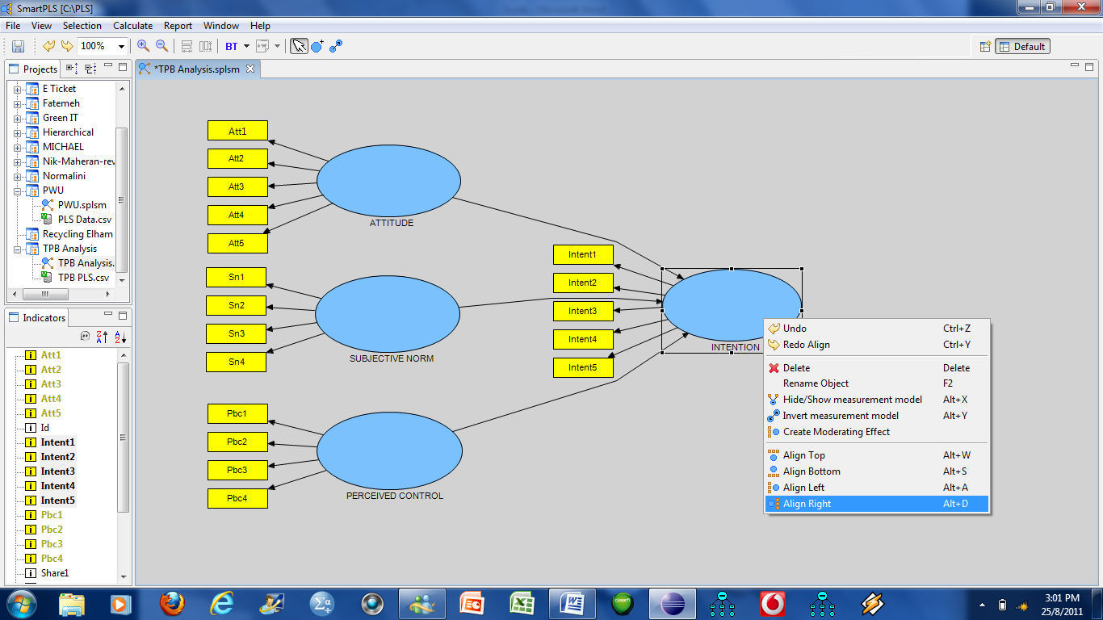

Right click the mouse at the Intention latent variable, a box will appear, choose Align Right.

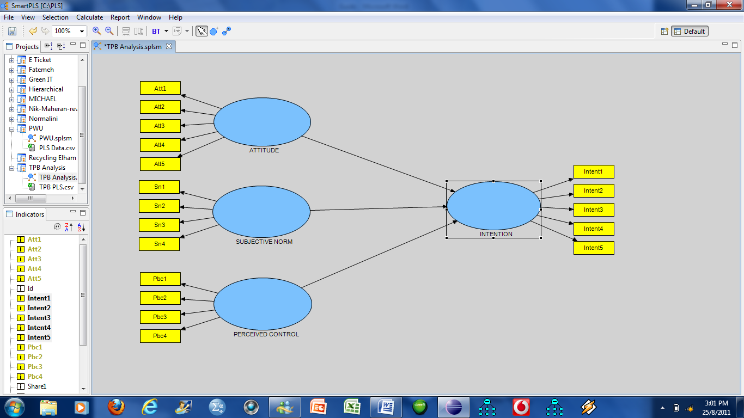

Now we are ready to run the analysis. Before that click File, Save All. This will save the drawing and also attach the data file together.

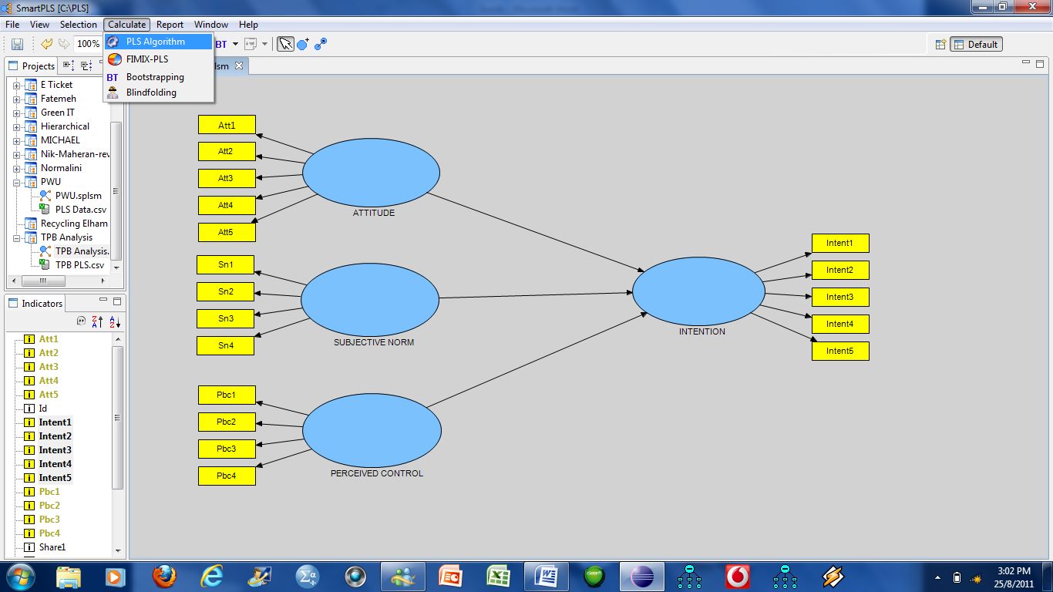

To run the analysis go to Calculate, and then choose PLS Algorithm.

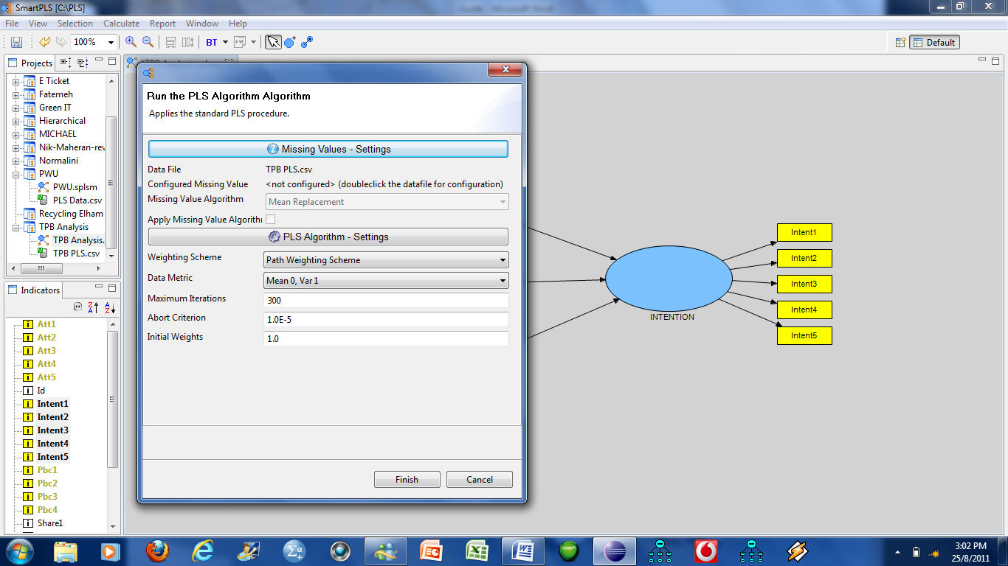

Just click Finish.

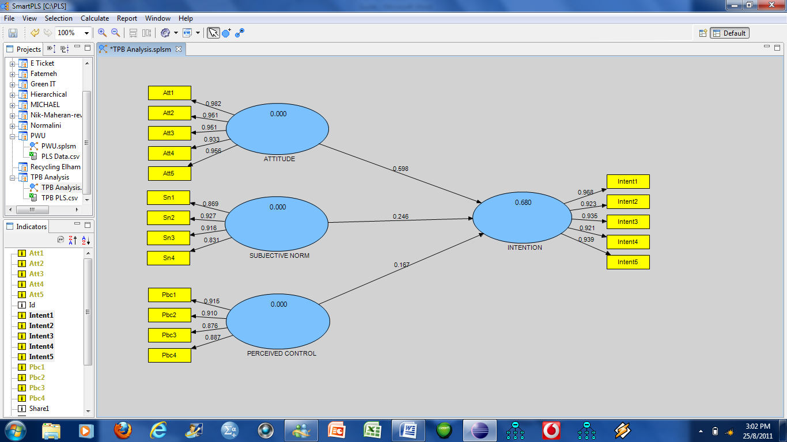

You have all the loadings and the R² which is 0.68.

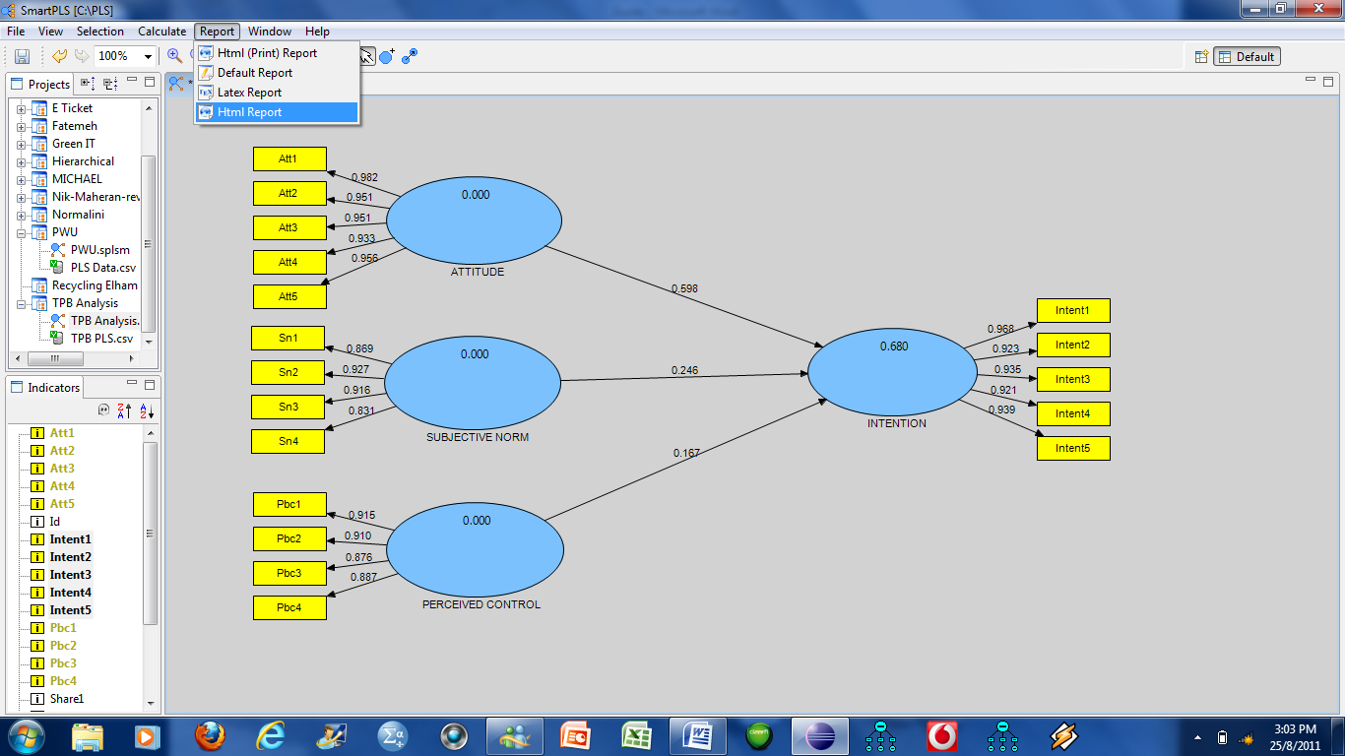

To generate the report, click Report, and then HTML Report.

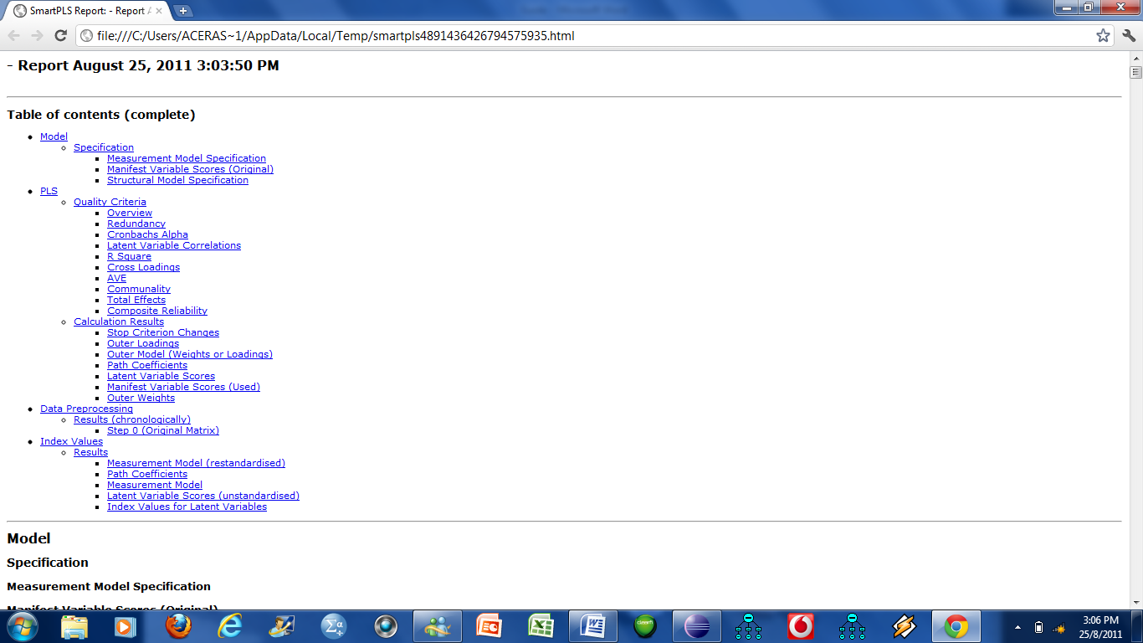

The output will open in a browser. The next few pages will show some of the outputs, not all are useful.

Model

PLS

Quality Criteria

Overview

 | AVE | Composite Reliability | R Square | Cronbachs Alpha | Communality | Redundancy
ATTITUDE | 0.911068 | 0.980846 |  | 0.975526 | 0.911068
INTENTION | 0.878506 | 0.973077 | 0.680251 | 0.965348 | 0.878506 | 0.524118
PERCEIVED CONTROL | 0.805075 | 0.942908 |  | 0.920143 | 0.805075
SUBJECTIVE NORM | 0.786227 | 0.936239 |  | 0.909000 | 0.786227
Redundancy

 | redundancy
ATTITUDE
INTENTION | 0.524118
PERCEIVED CONTROL
SUBJECTIVE NORM

Cronbachs Alpha

 | Cronbachs Alpha
ATTITUDE | 0.975526
INTENTION | 0.965348
PERCEIVED CONTROL | 0.920143
SUBJECTIVE NORM | 0.909000

Latent Variable Correlations

 | ATTITUDE | INTENTION | PERCEIVED CONTROL | SUBJECTIVE NORM
ATTITUDE | 1.000000
INTENTION | 0.798712 | 1.000000
PERCEIVED CONTROL | 0.195017 | 0.265564 | 1.000000
SUBJECTIVE NORM | 0.681782 | 0.642046 | -0.072508 | 1.000000

R Square

 | R Square
ATTITUDE
INTENTION | 0.680251
PERCEIVED CONTROL
SUBJECTIVE NORM
Cross Loadings

 | ATTITUDE | INTENTION | PERCEIVED CONTROL | SUBJECTIVE NORM
Att1 | 0.982058 | 0.802715 | 0.207770 | 0.683359
Att2 | 0.950548 | 0.785944 | 0.255108 | 0.657718
Att3 | 0.950990 | 0.731074 | 0.185310 | 0.660745
Att4 | 0.932559 | 0.741412 | 0.159137 | 0.609627
Att5 | 0.955673 | 0.746772 | 0.118222 | 0.640426
Intent1 | 0.800135 | 0.968406 | 0.209761 | 0.639149
Intent2 | 0.679831 | 0.922651 | 0.263355 | 0.546138
Intent3 | 0.745078 | 0.935071 | 0.270986 | 0.618954
Intent4 | 0.755138 | 0.920665 | 0.243018 | 0.580843
Intent5 | 0.756187 | 0.938857 | 0.260817 | 0.618142
Pbc1 | 0.223552 | 0.286670 | 0.915204 | -0.006074
Pbc2 | 0.173805 | 0.235236 | 0.909837 | -0.085683
Pbc3 | 0.135911 | 0.191623 | 0.876409 | -0.106393
Pbc4 | 0.148786 | 0.221453 | 0.887022 | -0.084339
Sn1 | 0.607790 | 0.577627 | -0.051632 | 0.868599
Sn2 | 0.654338 | 0.642245 | -0.026573 | 0.927470
Sn3 | 0.620459 | 0.555899 | -0.087130 | 0.916352
Sn4 | 0.523762 | 0.485033 | -0.103919 | 0.830989
AVE

 | AVE
ATTITUDE | 0.911068
INTENTION | 0.878506
PERCEIVED CONTROL | 0.805075
SUBJECTIVE NORM | 0.786227

Communality

 | communality
ATTITUDE | 0.911068
INTENTION | 0.878506
PERCEIVED CONTROL | 0.805075
SUBJECTIVE NORM | 0.786227
Total Effects

 | ATTITUDE | INTENTION | PERCEIVED CONTROL | SUBJECTIVE NORM
ATTITUDE |  | 0.598349
INTENTION
PERCEIVED CONTROL |  | 0.166726
SUBJECTIVE NORM |  | 0.246191
Composite Reliability

 | Composite Reliability
ATTITUDE | 0.980846
INTENTION | 0.973077
PERCEIVED CONTROL | 0.942908
SUBJECTIVE NORM | 0.936239

Outer Loadings

 | ATTITUDE | INTENTION | PERCEIVED CONTROL | SUBJECTIVE NORM
Att1 | 0.982058
Att2 | 0.950548
Att3 | 0.950990
Att4 | 0.932559
Att5 | 0.955673
Intent1 |  | 0.968406
Intent2 |  | 0.922651
Intent3 |  | 0.935071
Intent4 |  | 0.920665
Intent5 |  | 0.938857
Pbc1 |  |  | 0.915204
Pbc2 |  |  | 0.909837
Pbc3 |  |  | 0.876409
Pbc4 |  |  | 0.887022
Sn1 |  |  |  | 0.868599
Sn2 |  |  |  | 0.927470
Sn3 |  |  |  | 0.916352
Sn4 |  |  |  | 0.830989
Path Coefficients

 | ATTITUDE | INTENTION | PERCEIVED CONTROL | SUBJECTIVE NORM
ATTITUDE |  | 0.598349
INTENTION
PERCEIVED CONTROL |  | 0.166726
SUBJECTIVE NORM |  | 0.246191

Outer Weights

 | ATTITUDE | INTENTION | PERCEIVED CONTROL | SUBJECTIVE NORM
Att1 | 0.220786
Att2 | 0.216173
Att3 | 0.201081
Att4 | 0.203925
Att5 | 0.205399
Intent1 |  | 0.224833
Intent2 |  | 0.196039
Intent3 |  | 0.215551
Intent4 |  | 0.212861
Intent5 |  | 0.217142
Pbc1 |  |  | 0.340964
Pbc2 |  |  | 0.279789
Pbc3 |  |  | 0.227916
Pbc4 |  |  | 0.263396
Sn1 |  |  |  | 0.287399
Sn2 |  |  |  | 0.319550
Sn3 |  |  |  | 0.276588
Sn4 |  |  |  | 0.241328

Index Values for Latent Variables

 | LV Index Values
ATTITUDE | 3.821453
INTENTION | 3.832807
PERCEIVED CONTROL | 3.486542
SUBJECTIVE NORM | 3.716736

TO GENERATE t-VALUES

To get the t-values for the item loadings and the path coefficients you need to run the bootstrapping procedure. Click Estimate, and then Bootstrapping.

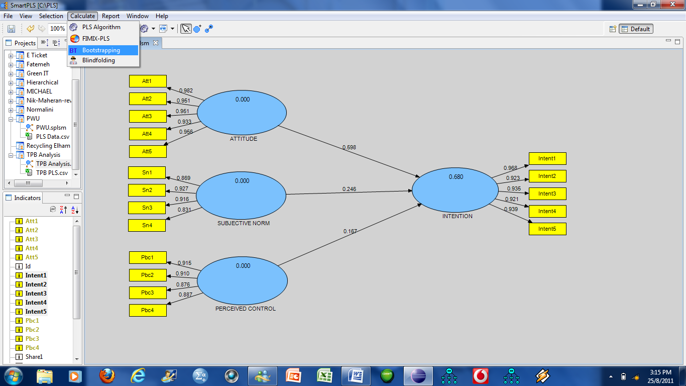

Another window will open up; here you need to input your sample size (the number of cases you have, in this data n=375) under the Cases, then you need to specify the number of re-samples for the bootstrapping under Samples. The number of re-samples suggested vary from 200 – 500.

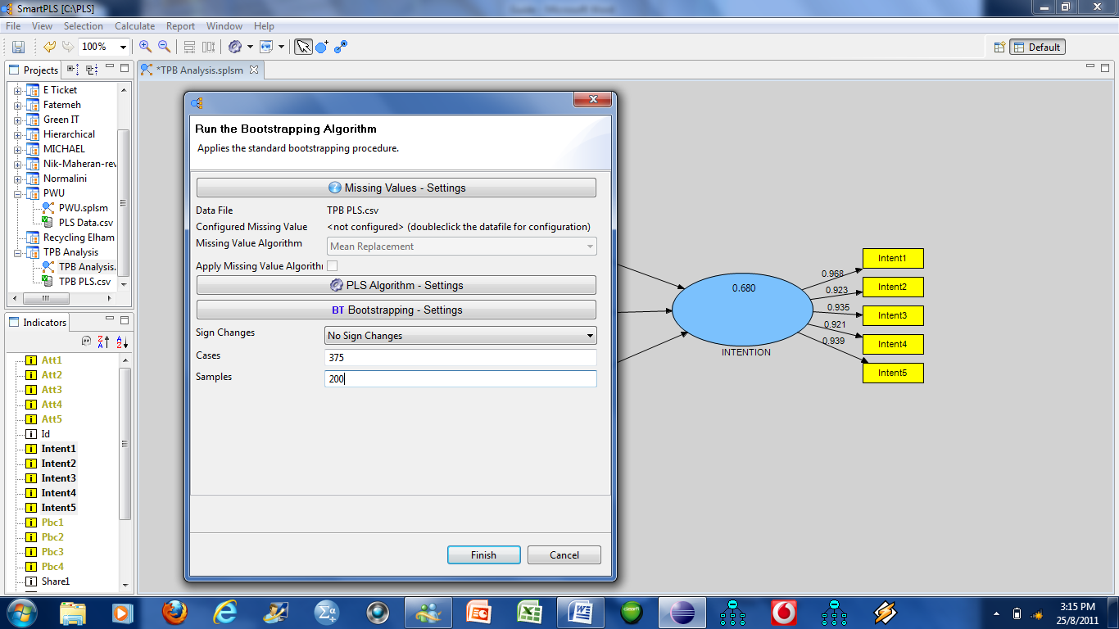

Once you click Finish, the following output will appear. The values shown now are the t-values, so if the t-value greater than 1.96 (p< 0.05) and if the t-value greater than 2.58 (p< 0.01)

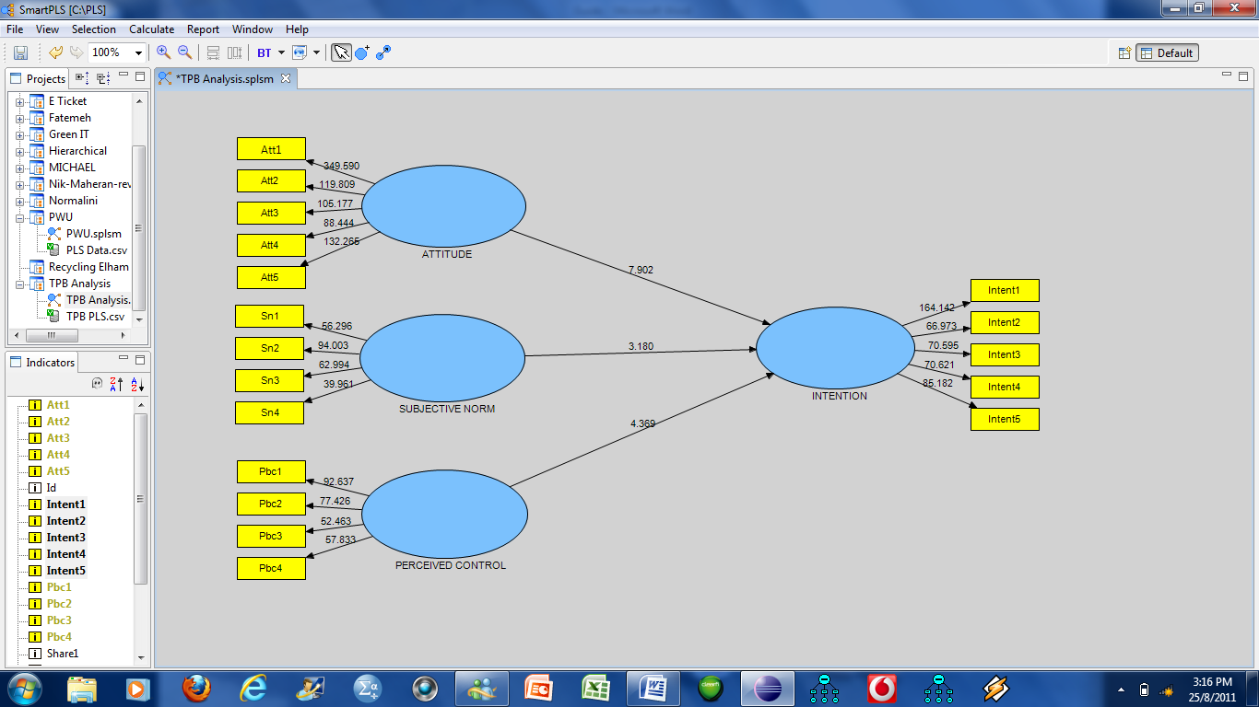

To get the output you can click on the Report, HTML Report.

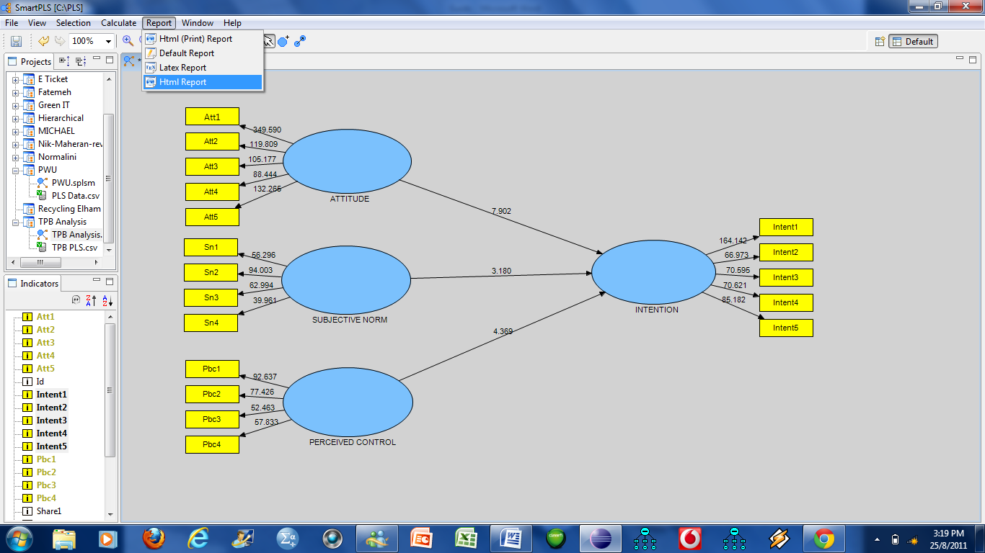

This is the start of the output which will open up in a browser.

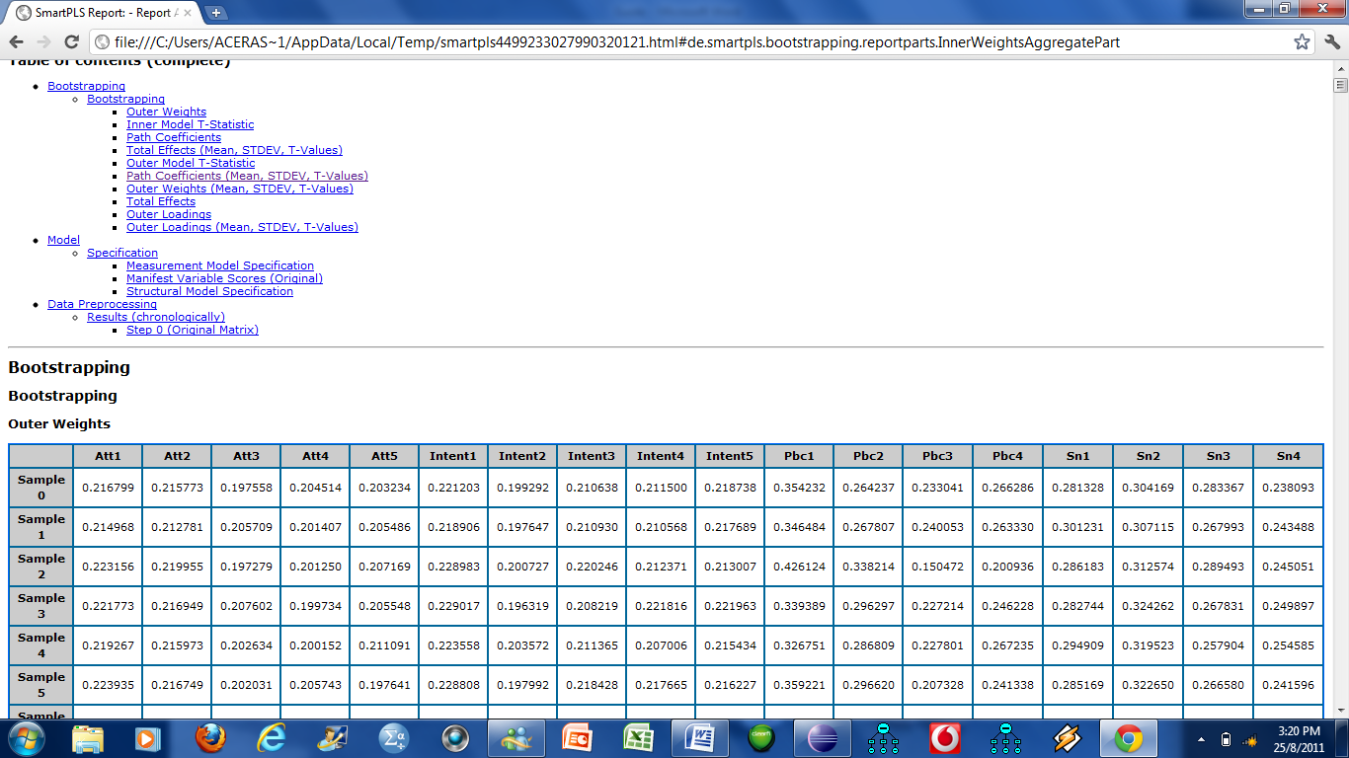

The only important table is the following, as the t-values are already given in the path diagram.

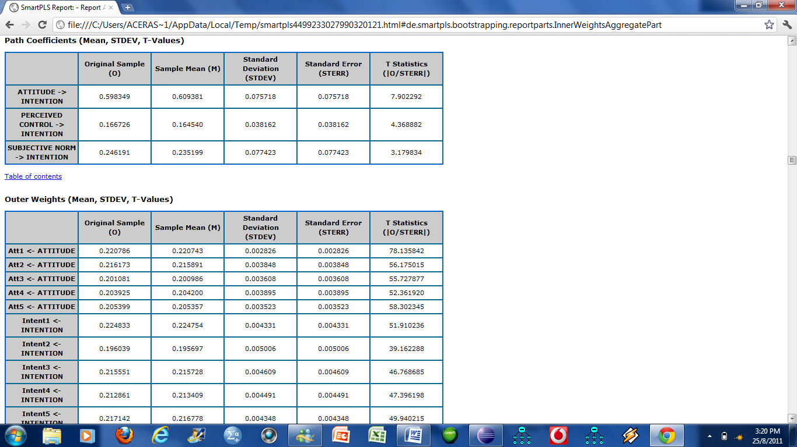

If you want to save the diagram, then click File, Export to Image. The diagram will be saved as a picture file.

